Predicting Customer’s Chrun

First Author1, Second Author2, Third Author3 & Fourth Author4

1first author student number and e-mail contact

2second author student number and e-mail contact

3third author student number and e-mail contact

4fourth author student number and e-mail contact

Abstract**:** maximum of 250 words, font Times New Roman, size 10, line spacing 1.0

Keywords: maximum three keywords separated by semicolon

Statement of Contribution: clearly state the contributions of each group member to the project

*Table of Contents*

Abstract I

Keywords I

Statement of Contribution I

List of Figures III

List of Tables III

I. Introduction 1

II. Description 1

a. Data 1

b. Problem 3

III. Pre-processing 4

IV. Modelling 11

a. Multilinear Regression 11

b. Logistic Regression (PCA/LDA) 11

c. Decision Tree Classifier 12

d. Random Forest Classifier 12

e. Support Vector Machine (SVM) 13

f. Naive Bayes Classifiers 14

g. Perceptron or Single-Layer Neural Network 14

V. Results 14

VI. Model Tuning 16

VII. Conclusions 17

VIII. Acknowledgements IV

IX. References V

# 

### List of Figures

Figure 1: Problem peculiarities 3

Figure 2: Null value check 4

Figure 3: Missing value check 4

Figure 4: Column Histograms 5

Figure 5: Column Boxplots 6

Figure 6: Exited vs Geography and Age 7

Figure 7: Exited vs Country 7

Figure 8: Number of Exits among Active and Inactive Members 8

Figure 9: Pair plot on selected variables 9

Figure 10: Heatmap 10

Figure 11: Example Decision Tree 12

Figure 12: Feature importance 13

Figure 13: Monetary score of each model 15

Figure 14: Accuracy of each model 15

Figure 15: Monetary score of each model after Cross-Validation 16

Figure 16: Final Monetary value of each model 16

### List of Tables

Table 1: Dataset 2

# Introduction

This report is part of the syllabus the course Introduction to Programming in the Master of Data Science and Advanced Analytics at Nova IMS and has the purpose to demonstrate programming skills in Python in a Data Science related manner.

The data set used for our project, further described later (cf. a. Data) contains sample data of bank customers of the year Y0. One of the variables is the binary variable “exited” indicating whether a customer is or no longer is a customer after time T1.

Our goal is to explore some machine learning techniques in order to predict if a customer is going to exit or not that is predicting the binary variable.

The remainder of this report is structured as following: first, the data set and problem is described (cf. II. Description), then the data is pre-processed (cf. III. Pre-processing) and different prediction models are introduced (cf. IV. Modelling). Afterwards the results of the models are compared (cf. V. Results). Then the two bests are being optimised (cf. VI. Model Tuning). In the end a conclusion is drawn (cf. VII. Conclusions).

# Description

In this section the dataset is described in terms of each variable. Also, the problem is described.

## Data

The main and only dataset used for this project contains detailed information of a random sample of customers from a European bank. The data in question was taken from the bank’s database on the 31st of December 2017. Meaning the data is static and of very high quality as it will be seen on the following sections of the report.

Six months after the initial data collection, it was recorded if the customers continued to be in business with the bank. This additional data will be used as the independent variable.

The data previously described can be found on the file *Churn_Modelling.csv*. The columns contained are the following:

|  |  |  |
| --- | --- | --- |
| **Field** | **Format** | **Description** |
| **RowNumber** | int64 | The row number (index from database table). Numeric value in the range of <1;1000> |
| **CustomerId** | int64 | The unique Customer ID ranging between 15565701 and 15815690. This is the most granular attribute in the dataset. |
| **Surname** | object | Customer’s surname. |
| **CreditScore** | int64 | Credit Score of a customer ranging between 300 and 850. A higher implies a higher ‘credit worthiness’. |
| **Geography** | object | Branch location that a customer belongs to. There are three possible discrete values: ‘France’, ‘Germany’ or ‘Spain’. |
| **Gender** | object | Gender of the customer. There are two possible Boolean values: ‘Male’ or ‘Female’}. |
| **Age** | int64 | Customer’s age on the day the data was collected (31/12/17). This age will also be applicable 6 months later. The ages range between 18 and 92. |
| **Tenure** | int64 | Number of years a customer has been with the business. The years range between 0 and 10. |
| **Balance** | float64 | Average amount of money in the bank account on December 2017. The Average was calculated by summing account balance for each day in the month and divided by number of days in that specific month. The Sum of the average amount can be significantly different from sum of the actual account balance of customers but for static data using only one-day info can be very misleading. |
| **NumOfProducts** | int64 | The number of products a customer has with the bank. The number ranges between 1 and 4. |
| **HasCrCard** | int64 | Boolean value representing if a customer has a credit card or not. 1 if the customer has and 0 if the customer doesn’t. The dataset contains 7055 customers who possess a credit card (value 1) and 2945 who don’t (value 0). |
| **IsActiveMember** | int64 | Boolean value representing if a customer is active or not. 1 if the customer is and 0 if the customer isn’t. |
| **EstimatedSalary** | float64 | Estimated annual salary of the customer. The salaries in USD range between 11.58 and 199992.48. |
| **Exited** | int64 | Boolean value representing if a customer left the bank after 6 months or not. 1 if yes and 0 if no. |

Table 1: Dataset

## Problem

For the purpose of this report the following fictional problem is introduced:

The marketing department of a bank has developed a campaign which prevents customers from leaving the company. This campaign is to be executed a data set from the current year Y1.

The goal for us, as aspiring Data Scientists, is to maximize the return on investment of the marketing campaign, that is predicting which customer is going to leave and which is not.

Later, we are going to use the campaign information to evaluate the performance of different prediction models.

The marketing department specified the following parameters of the campaign:

* Cost of applying the campaign per customer: 150€
* Average customer value till T1: 450€,
* Average customer value from T1 till T2: 650€
* Moreover, applying the campaign to a customer which had not been leaving still has some positive effect on the customer’s likelihood to leave the bank in the future. This effect is quantified as: 10€
* Assumption at time T0: no costumer leaves till T1 (for simplicity)
* Customers who were prevented from leaving will stay till T2

Four cases can be derived from the above for the training data set:

Figure 1: Problem peculiarities

If a customer leaves till T1 and no campaign is applied:

**loss of 450€**

(money expected to be gained by T1)

If a customer does not leave and no campaign is applied:

**no loss or gain**

(everything happened as excepted till T1

If a customer does not leave because the campaign is applied:

**gain of 500€**

(no loss of 450€ by T1, a gain of 650€ because the customer is going to stay till T2, a loss for applying the campaign of 150€)

If a customer does not leave and was not going to leave but the campaign is applied:

**loss of 140€**

(no loss of 450€ by T1, a loss for applying the campaign of 150€, a gain for the positive effect of the campaign of 10€)

Customer does not leave

Customer leaves

Customer does not leave

Customer leaves

*Model prediction (applying the campaign or not)*

*Reality*

# Pre-processing

In the pre-processing part we perform an exploratory data analysis in order to gain more insights on the dataset and justify data transformation performed on the dataset, preparing it for the modelling part.

Handling null values

As previously mentioned the analysed dataset presents high quality which can be proved with no missing values (Figure 3 and Figure 2). We are then able to skip the null handling part focus on other aspects of data pre-processing.

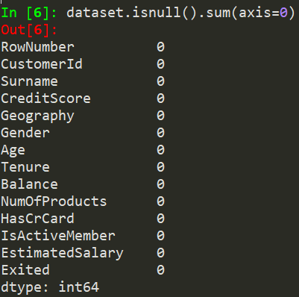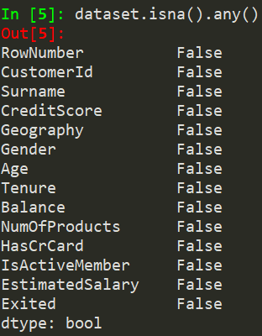

Figure 2: Null value check

Figure 3: Missing value check

Feature selection

As a second step of data pre-processing (after identifying null values), non-useful for the problem columns have been dropped ([Surname], [CustomerId], [RowNumber]). Afterwards, histograms of non-binary columns are useful for insights about data distribution (cf. Figure 4).

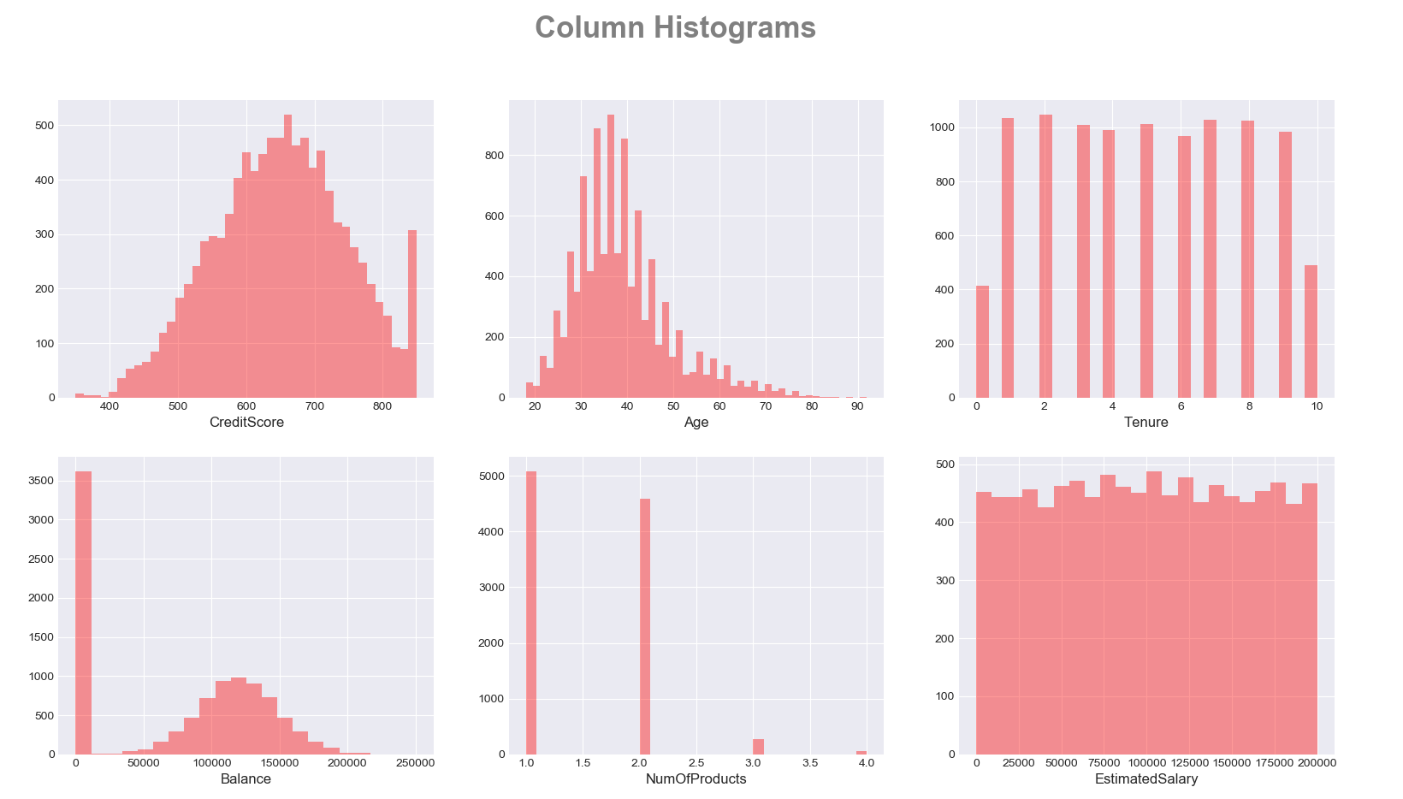

Figure 4: Column Histograms

Handling skewness

The third step of data pre-processing includes logarithmic transformation of columns with skewed distribution (c.f [‘Age’] in Figure 4). As a result, the distribution of transformed column is more similar to normal, which is proved at the boxplot below.

Outliers detection

The forth step of data pre-processing includes outlier identification. For that purpose, boxplots of non-binary columns were plotted (cf. Figure 5). Points above whiskers are considered as extreme values but not outliers, as they present credible values. Data distribution is normal for all variables with the exception of [NumofProducts] and [Balance], where it is appears (former) and left (latter) skewed.

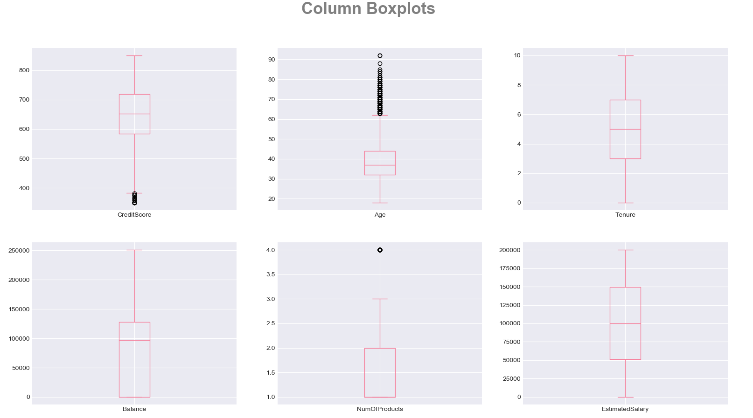

Figure 5: Column Boxplots

Categorical variables encoding

Categorical variables, such as [Gender] and [Geography] have been one-hot encoded so we are able to include them in the model. To avoid the dummy variable trap we reduce the encoded dummy columns by on only keeping [Germany, Spain] for Geography [ http://www.algosome.com/articles/dummy-variable-trap-regression.html].

In the following section we will be looking at the categorical variables and at how they correlate with some of the numerical variables analysed previously. This analysis will be conducted with the use of visual representations.

Exited vs Geography and Age

The following graph shows how the age and location of the branch are correlated to the independent variable (cf. Figure 6). It can be observed that customers left the business at a similar rate in all three locations. Spain lost the least number of customers and Germany the highest. The bulk of the population that remained a customer of the bank is between the range of 25 and 45 years of age in all branches. It would be expected that the older a customer is the more loyal he would be to a business, but this graph proves the contrary. Ultimately, the graph shows the peak of customers leaving is at around 45 years old in all three countries.

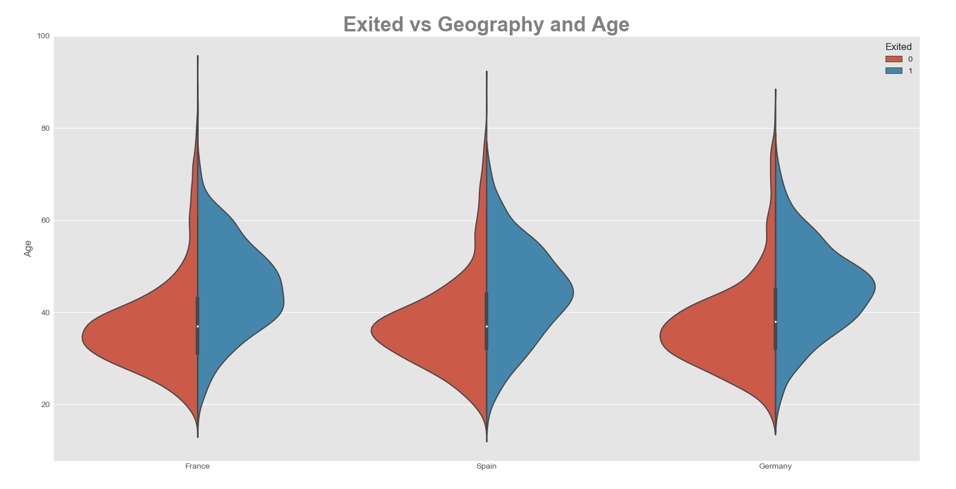

Figure 6: Exited vs Geography and Age

Exited vs Country

Figure 7 solidifies the point that Germany is the country were customers tend to leave the business the most. As it can be seen France is the country with the lowest number of customers leaving but it does not differ much from Spain.

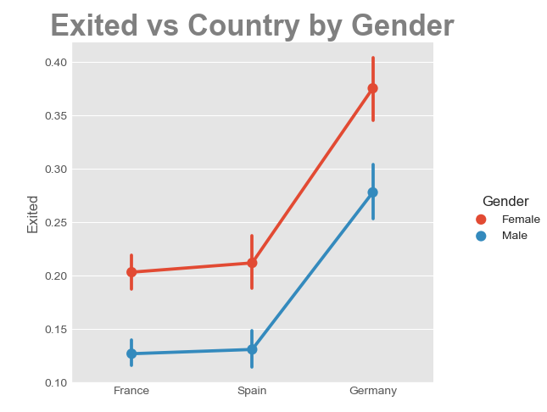

Figure 7: Exited vs Country

Exited vs Members Activity

The histogram (Figure 8), shows if both active and inactive customers left the bank or not. It would be to expect that inactive customers have a higher tendency to leave. The histogram shows that the prediction is correct but the difference is minimal.

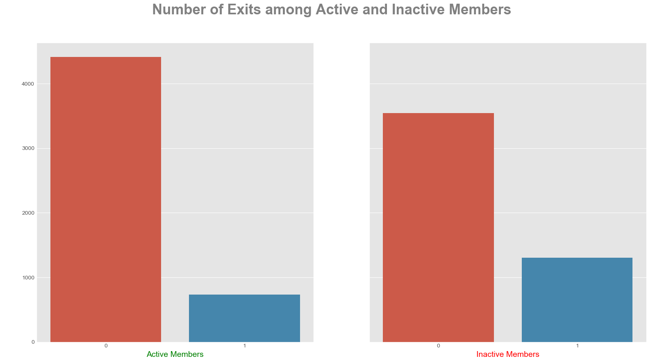

Figure 8: Number of Exits among Active and Inactive Members

Pair Plot

We are using a pair plot to see relationships between two variables [https://towardsdatascience.com/visualizing-data-with-pair-plots-in-python-f228cf529166]. Figure 9 is a pair plot on the tree variables CreditScore, Age and Balance with the hue of Exited. People who exit are on average older (cf. plot [2][2]). Moreover, Age also has an influence on the distribution of customers Balance (cf. plot [3][2]) and likewise on the CreditScore (cf. plot [1][2]). Other variable distributions (other than Age) do not allow much interpretation (therefore this selection).

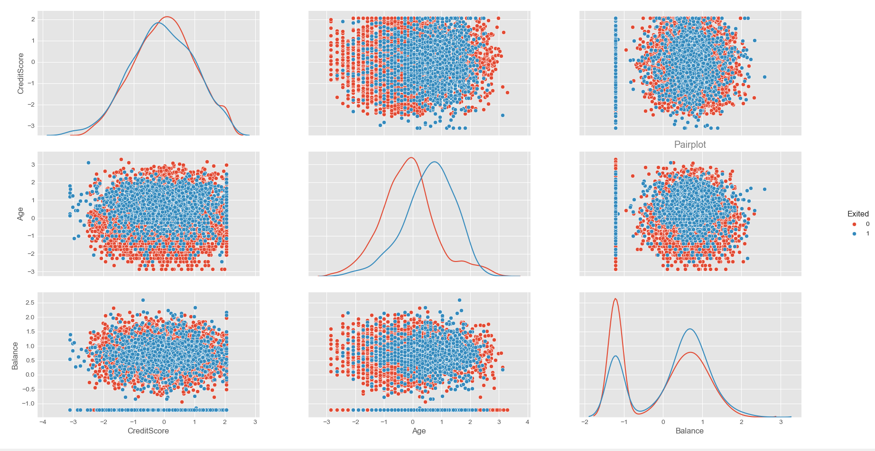

**Pair plot**

Hidden

Figure 9: Pair plot on selected variables

Data Correlation

Before modelling it is important to get insights on the correlation between variables. Figure 10 illustrates it graphically and with percentage notation using the Pearson correlation in a heat map. The Balance is influenced by the customers region, a phenomenon which is explained by finance theory [fiancé theory]. Having introduced Dummy variables for location a correlation is normal. The correlation of NumOfProducts and Balance is higher than any other (-30% vs less than +/-6%) however we decided to include in for further modelling as it is not extremely high.

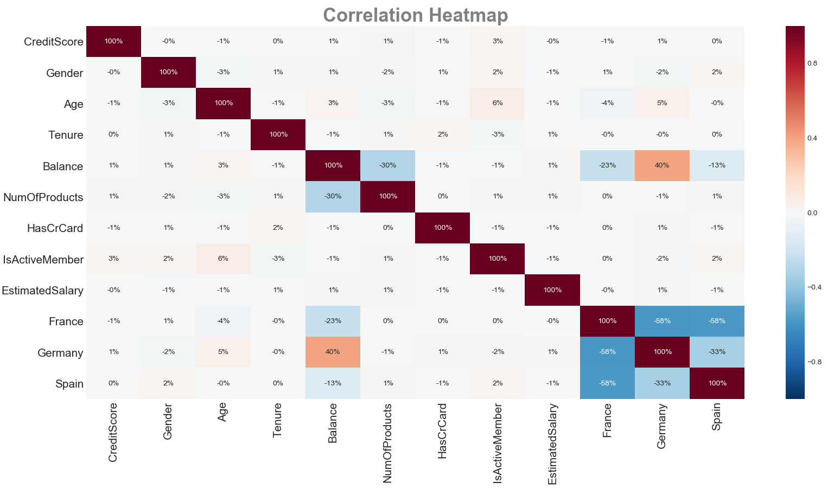

Figure 10: Heatmap

Train test split and scaling

Before Modelling we are splitting the data into a training and a test set. The training set contains a known output and the models learns on this data in order to be generalized to other data later on. The test set is used to test our model’s prediction. [?].

Further we scale the train data using the Z score normalization because normalized data is an assumption of many machine learning algorithms (such as SVM, K-nearest neighbours, and logistic regression). Standardization involves rescaling the features such that they have the properties of a standard normal distribution with a mean of zero and a standard deviation of one. Afterwards we apply the same scale on our test set[9]. Scaling is done after splitting for test and train because otherwise the training set would include information of the test set.

# Modelling

In this section we introduce the machine learning models we applied to our test data set.

## Multilinear Regression

Regression is one of the most basic and popular approaches to prediction, that’s why it is common to perform linear regression as a first model. Although linear regression is not designed to make binary classification you can predict continuous value with it and afterwards use some threshold to classify those values into two categories. There are two popular approaches in doing this. One is in using a 0.5 threshold, if predicted value is above that level, you predict 1 and when exactly that or less it you predict 0. This method seems to be logical from mathematic point of view, but the predicted values don’t necessary lay in a range <0;1> that is why a new approach has been developed, to calculate threshold by taking the mean of the range of predicted values, or median if distribution of those data are skewed. Additionally by applying backward elimination strategy you can get more inside about importance of each variable and magnitude of the effect.

## Logistic Regression (PCA/LDA)

Logistic Regression is a classification algorithm that tries to predict the probability of a binary categorical variable, two classes. It is said to have a linear boundary between two possible results [**https://codesachin.wordpress.com/2015/08/16/logistic-regression-for-dummies/**]. This is perfect to test with our data as the dependent variable is if a customer exited the business or not. This module is also best used in large data samples. A disadvantage is that the module assumes independent variables have little multicollinearity and as it can be seen in the data extraction section of the report that is not always true [**https://towardsdatascience.com/building-a-logistic-regression-in-python-step-by-step-becd4d56c9c8**]. A solution to this is to transform the data before it goes through the Logistic Regression model. This can be done with Linear Discriminant Analysis, LDA, and Principal Component Analysis, PCA. These are both techniques used for linear transformation.

PCA is used to reduce the dimensions of a dataset, meaning it tries to use fewer components to explain the outcome. It is usually used to make sure there is no correlation between independent, and like this make the logistic regression model more efficient. [https://towardsdatascience.com/a-one-stop-shop-for-principal-component-analysis-5582fb7e0a9c] It also does not take into account class membership meaning it is unsupervised.

LDA on the other hand tries to maximize class separation meaning it is supervised. [**https://www.researchgate.net/post/What_is_the_difference_between_PCA_FA_and_LDA**]

[**https://machinelearningmastery.com/linear-discriminant-analysis-for-machine-learning**/]

## Decision Tree Classifier

The decision tree classifier is a supervised learning method, which can be applied in both regression and classification problems [ISLR]. Given our binary classification problem described in the introduction [cf. XX] applying a decision tree model is possible. In addition, decision trees are able to outperform linear (regression) models if the classification boundary is of non-liner type as linear models won’t be able to capture the decision boundary [ISLR]. An additional benefit is that decision trees are able to perform multi class classification problems [SCIKIT], however given our binary classification problem this is of little use. Another aspect making decision tree model very suitable for our problem is, that decision trees are applicable for continuous and categorical data [DM][cf. data description], which makes their implementation easier. Moreover, they can also handle incomplete data [DM][SCIKIT].

Without going into much detail, decision trees are trained through splitting the data into sub categories according to some criteria (Entropy or Gini index etc.). The trained tree then classifies the data based on its relation to the different splits. This allows a high interpretably of the dataset itself and the functioning of the decision tree, especially because a decision tree is easy to visualize (cf. Figure 11)[UDEMY][DM].

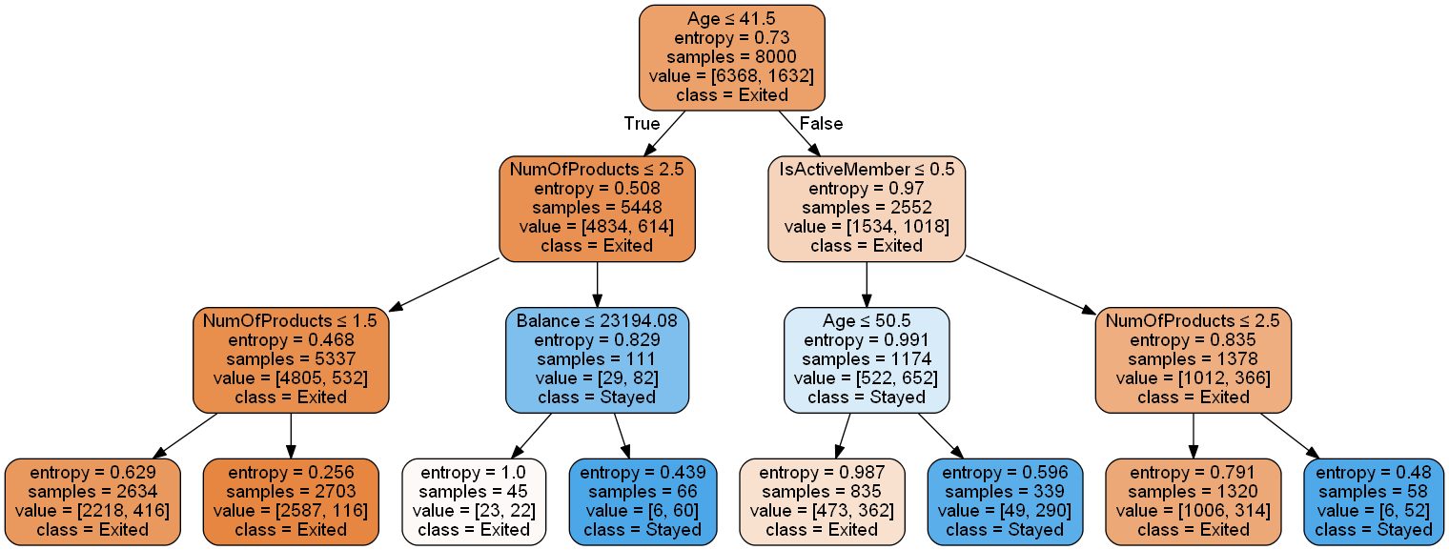

Figure 11: Example Decision Tree

## Random Forest Classifier

Decision-tree models can create over-complex trees that do not generalize the data well. This is called overfitting. This problem can be overcome by aggregating multiple decision trees e.g. in a random forest using ensemble methods [Breiman, L (2001)][ISLR]. Because the random forest method is based on multiple (random generated) trees it inherits many good characteristics as being applicable in both regression and classification problems and being able to deal with categorical and continuous data [DM][ISLR] making it suitable for our project. Using a large number of trees can often result in dramatic improvements in prediction accuracy, compared to single decision trees at the expense of some loss in interpretation. ISLR [towardsdatascience.com] However, the relative feature importance can be derived (cf. Figure 12) [DM]. The random forest decorrelates trees compared to other aggregated tree models [e.g. bagging]; important when dealing with multiple features which may be correlated. which is why Random forests is considered as a highly accurate and robust method [DATACAMP] [ISLR]. However, it is important to mention that a large number of trees can make the algorithm to slow and ineffective for real-time predictions. While random forests are fast to train, they are slow to create predictions once they are trained [DM][DATACAMP]. A more accurate prediction requires more trees, which results in a slower model, following the no free lunch theorem [Wolpert, Macready (1997)].

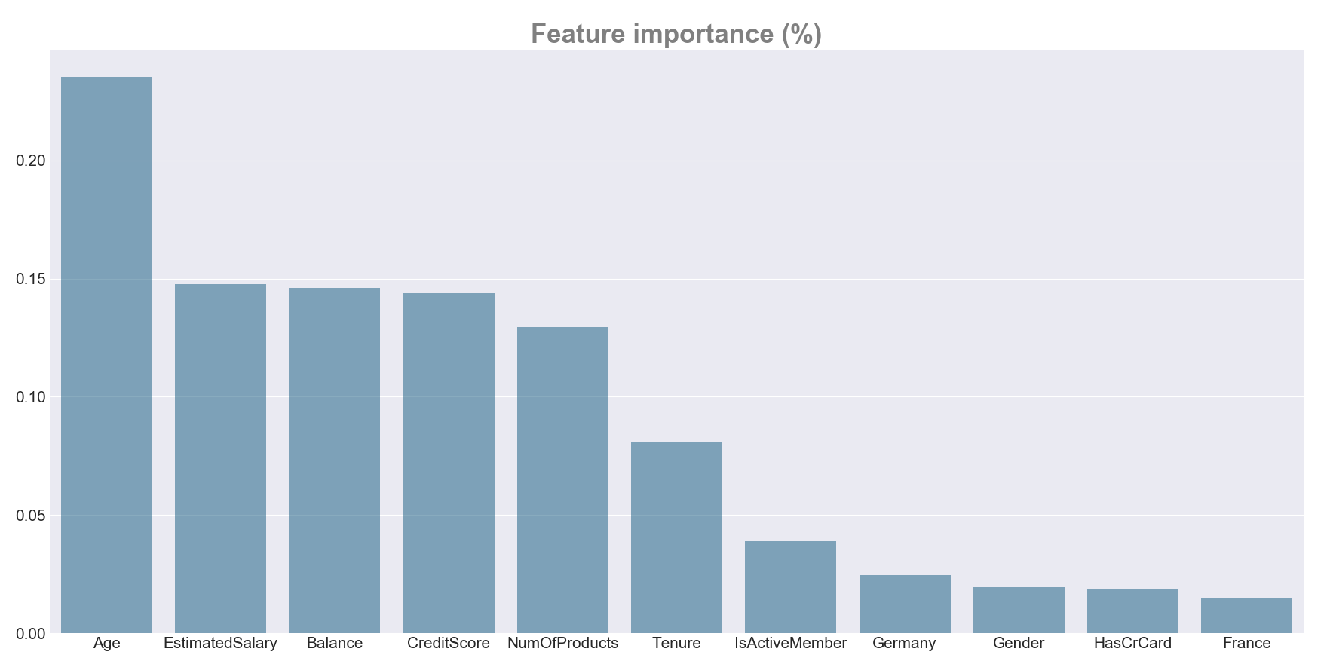

Figure 12: Feature importance

## Support Vector Machine (SVM)

A special kind of machine learning algorithm that uses the idea of Maximum Margin between the Support Vectors was used as an attempt to outperform previous algorithms for solution to our classification problem. Support Vector Machines is an extremely popular algorithm because of its efficiency and ability to tackle both: classification and regression problems. Additionally, the algorithm can be useful for both Linearly Separable (hard margin) and Non-linearly Separable (soft margin) data thanks to the proper C parameter tuning [www.towardsdatascience.com]. Moreover, the SVM uses the ‘Kernel Trick’ thanks to which it is able to capture complex relationships between data points without having a problem to perform difficult transformations. This algorithm presents some kind of a different approach to our problem, as SVM is ‘rebellious’ itself since unlike most of the common algorithms, it uses extreme cases, close to the hyperplane (boundary) between the classes for its analysis. The downside of SVM is that the training time takes a relatively long time, but this is a suitable algorithm for the volume of data that we are working with in this case. [Introduction to Statistical Learning] Author: Gareth James. For better results, hyperparameters running was performed by means of Grid Search on 2 of algorithm’s parameters.

## Naive Bayes Classifiers

The Naive Bayes model is not a single classifier, but a family of classification algorithms based on the statistical theorem of Bayes [**http://blog.aylien.com/naive-bayes-for-dummies-a-simple-explanation**/]. Shortly explained, Bayes’ theorem uses prior knowledge of an event to more accurately predict the outcome of said event **[https://brilliant.org/wiki/bayes-theorem/].**

Every Naive Bayes classifier works from the same principle that every condition of the dependent variable is unique, not taking any correlation between independent variables into account.

Three types of Naive Bayes classifiers were tested: Multinomial, Bernoulli and Gaussian. Multinomial is used for categorical variables. Bernoulli is also categorical focused but it works with binary variables. Gaussian takes numerical continuous variables as predictors [**https://towardsdatascience.com/naive-bayes-classifier-81d512f50a7c**].

To sum up, Naive Bayes is a very fast module due to being very simple and easy to implement. Its only disadvantage, as mentioned above, is the fact that it does not take the correlation between independent variables as a predictive factor. This leads to a loss of valuable information.

## Perceptron or Single-Layer Neural Network

The Perceptron or Single-Layer Neural Network is a machine learning technique belonging to the supervised learning methods to perform binary classification. A binary classifier is a function which can decide whether or not an input, represented by a vector of numbers, belongs to some specific class. It is a type of linear classifier, i.e. a classification algorithm that makes its predictions based on a linear predictor function combining a set of weights with the feature vector [10].

# Results

As a result of data cleaning, data exploratory analysis, and 6 machine learning algorithms implementation with default settings, we were able to predict the customer decision about exiting the store with 70-83% of accuracy.

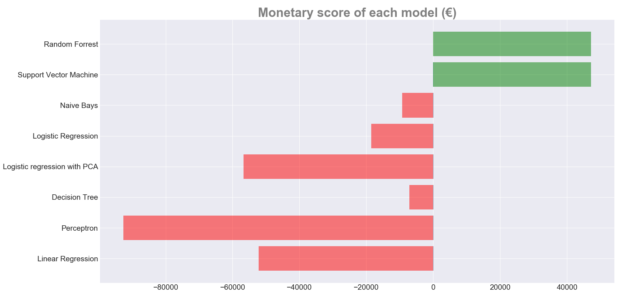

Figure 13: Monetary score of each model

But since output is not equally distributed in the data set, it is not advisable to focus merely on the statistical accuracy (that is one of the reasons why we introduced a new monetary formula to measure how precise our models are in real business terms). Although differences in accuracy were almost indistinguishable, a significant difference in models performance have been identified in the monetary value. This is because the correct prediction of customers who are going to stay is much less valuable to the company than the correct predictions of customers who are going to leave. Additionally, a wrong prediction of customers who are going to leave costs the company three times as much as the wrong prediction of customers who are going to stay.

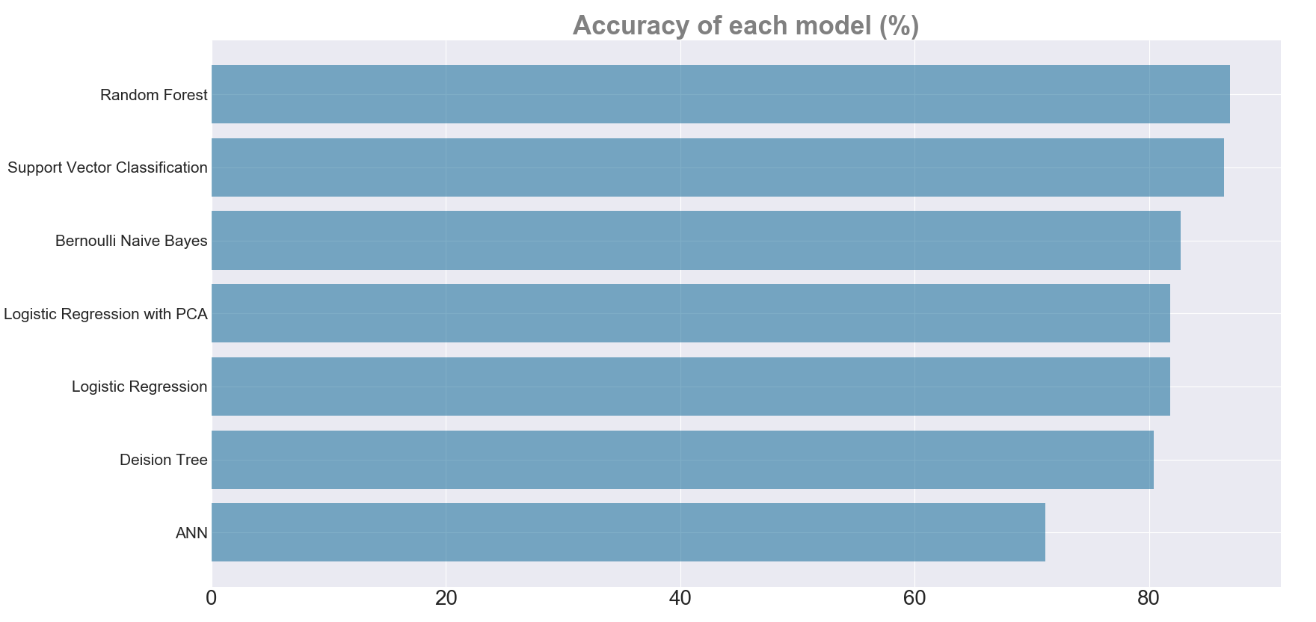

Figure 14: Accuracy of each model

Before we decide how to make our model better, let's determine which of our models are not worth keeping for further analysis. Since three of the models (Logistic Regression with PCA, Decision Tree and Perceptron) are significantly worse than the others, we decided to exclude them from further analysis. Before deciding on which models are the most promising, a cross validation has been performed in order to exclude the possibility of making wrong conclusions caused by randomness which could be a result of a one-time model testing on a single test data set.

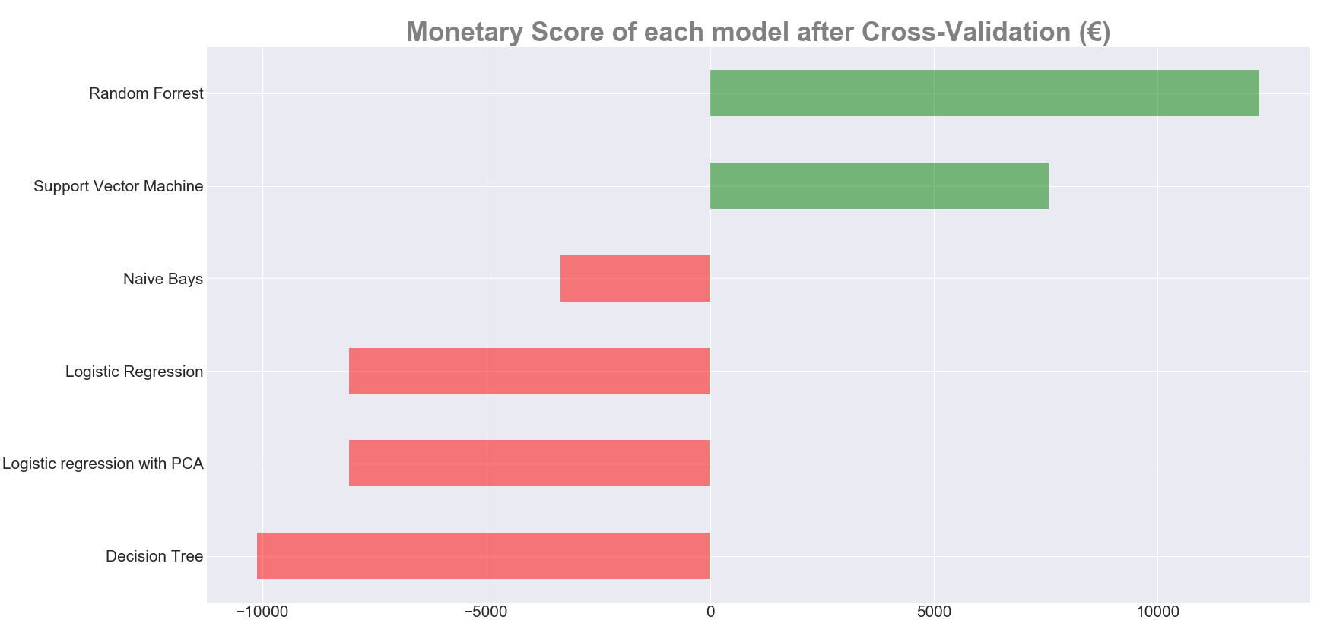

Figure 15: Monetary score of each model after Cross-Validation

After cross validating the model performance we are able to conclude that two models perform significantly better than any other model. It turned out that in this specific problem instance Random Forest and Support Vector Classification are able to provide the most valuable classification of customers.

# Model Tuning

In order to tune the models for even better performance, a Grid Search has been performed in to find the best combination of parameter settings. As a result, Monetary Score has increased in both models by [X] for Random Forest and by [Y] for Support Vector Classifier. As it can be seen at the Figure [], grid search brought better results for Random Forest, which indicates that good parameter settings turned out to be more relevant for that model.

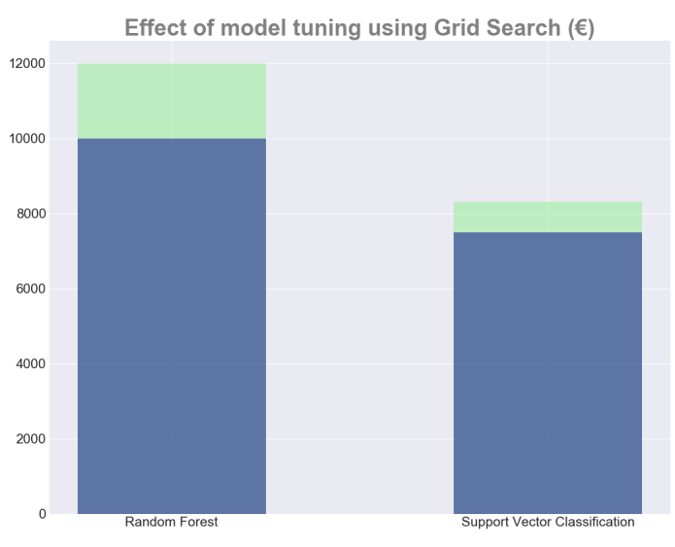

Figure 16: Effect of model tuning using Grid Search

# Conclusions

To conclude, Random Forest proved to be the best model for our problem instance and it enables the company to gain [XXX] of profit by proper marketing campaign implementation. One of core conclusions to draw from this project is the fact that there is no perfect way of measuring how good the model is and which approach is the most reasonable. Thus, we decided to approach the problem from a business perspective rather than focusing on statistical model evaluation measures like accuracy or sensitivity. Moreover, for this specific problem instance choosing the best model is a difficult but very important process, as wrong choice of these two features may even lead to losses of income if the marketing strategy is applied to a wrong group of people. That is why, we have created our own, problem-specific formula for model assessment. The work-flow process included testing a wide range of models and gradually excluding the worst performing ones from further analysis. This way, we managed to successfully select one best performing model that scores the highest result. Finally, using the proper model with the right parameters, after having spent enough time collecting and preprocessing data we were able to turn theoretical data science knowledge into real profit for the company. Having spent even more time on feature engineering, model tuning and implementing more advanced models like adaboost, gradient boost or xgboost can lead to better results but there is a trade-off between how much additional time we would have to spend and by how much we can improve our model. This trade-off has to be taken into consideration when deciding.

# Acknowledgements

Use this section to acknowledge the contribution of a third party for your project, for instance additional mentoring or data acquisition, or if you are using data from your company for instance.

# References

* Aigiomawu, E. (2018). *Introduction to Matplotlib — Data Visualization in Python*. [online] Heartbeat. Available at: https://heartbeat.fritz.ai/introduction-to-matplotlib-data-visualization-in-python-d9143287ae39.
* Brownlee, J. (2014). *Naive Bayes Classifier From Scratch in Python*. [online] Machine Learning Mastery. Available at: <https://machinelearningmastery.com/naive-bayes-classifier-scratch-python/>.
* Anon, (2018). *Dimension Reduction Techniques (PCA vs LDA) in Machine Learning – Part 2*. [online] Available at: http://www.vfirst.com/blog/techfirst/dimension-reduction-techniques-pca-vs-lda-in-machine-learning-part-2/ .
* Han, J., Kamber, M. and Pei, J. (2012). *Data mining Concepts and Techniques*. Waltham: Morgan Kaufmann.
* James, G., Witten, D., Hastie, T. and Tibshirani, R. (2013). *An introduction to statistical learning*.
* Koehrsen, W. (2018). *A Complete Machine Learning Walk-Through in Python: Part One*. [online] Towards Data Science. Available at: https://towardsdatascience.com/a-complete-machine-learning-walk-through-in-python-part-one-c62152f39420?fbclid=IwAR01u2cAkJOhJpJM7QFCH821et3MzS9wI00a8W49mmgDNmYoZQDtd8dZpHM.
* Lei, P. and Koehly, L. (2003). Linear Discriminant Analysis Versus Logistic Regression: A Comparison of Classification Errors in the Two-Group Case. *The Journal of Experimental Education*, 72(1), pp.25-49.
* Ramis, J. (2017). *Logistic Regression PCA vs LDA comparison | Kaggle*. [online] Kaggle.com. Available at: https://www.kaggle.com/junad007/logistic-regression-pca-vs-lda-comparison.
* ZHANG, H. (2005). EXPLORING CONDITIONS FOR THE OPTIMALITY OF NAÏVE BAYES. *International Journal of Pattern Recognition and Artificial Intelligence*, 19(02), pp.183-198.
* (<https://www.datacamp.com/community/tutorials/random-forests-classifier-python#advantages>)
* (https://towardsdatascience.com/the-random-forest-algorithm-d457d499ffcd)
* Wolpert, D.H., Macready, W.G. (1997), "[No Free Lunch Theorems for Optimization](http://ti.arc.nasa.gov/m/profile/dhw/papers/78.pdf)", *IEEE Transactions on Evolutionary Computation* 1, 67.
* UDEMY <https://www.udemy.com/python-for-data-science-and-machine-learning-bootcamp/learn/v4/> by Jose Portilla
* SCIKIT <https://scikit-learn.org/stable/modules/tree.html>
* ISLR Gareth James • Daniela Witten • Trevor Hastie Robert TibshiraniAn Introduction to Statistical Learning DOI 10.1007/978-1-4614-7138-7
* DM ISBN 978-0-12-381479-1 (our data mining book)
* Random Forest Breiman, L. Machine Learning (2001) 45: 5. <https://doi.org/10.1023/A:1010933404324>
* [https://towardsdatascience.com/visualizing-data-with-pair-plots-in-python-f228cf529166]
* <https://scikit-learn.org/stable/auto_examples/preprocessing/plot_scaling_importance.html>].
* [Scikit-learn: Machine Learning in Python](http://jmlr.csail.mit.edu/papers/v12/pedregosa11a.html), Pedregosa *et al.*, JMLR 12, pp. 2825-2830, 2011.
* All Figures are own visualizations using the Seaborn module (10.5281/zenodo.1313201) and the Mathplot lib module (https://doi.org/10.5281/zenodo.1482099)

This page is left out intentionally